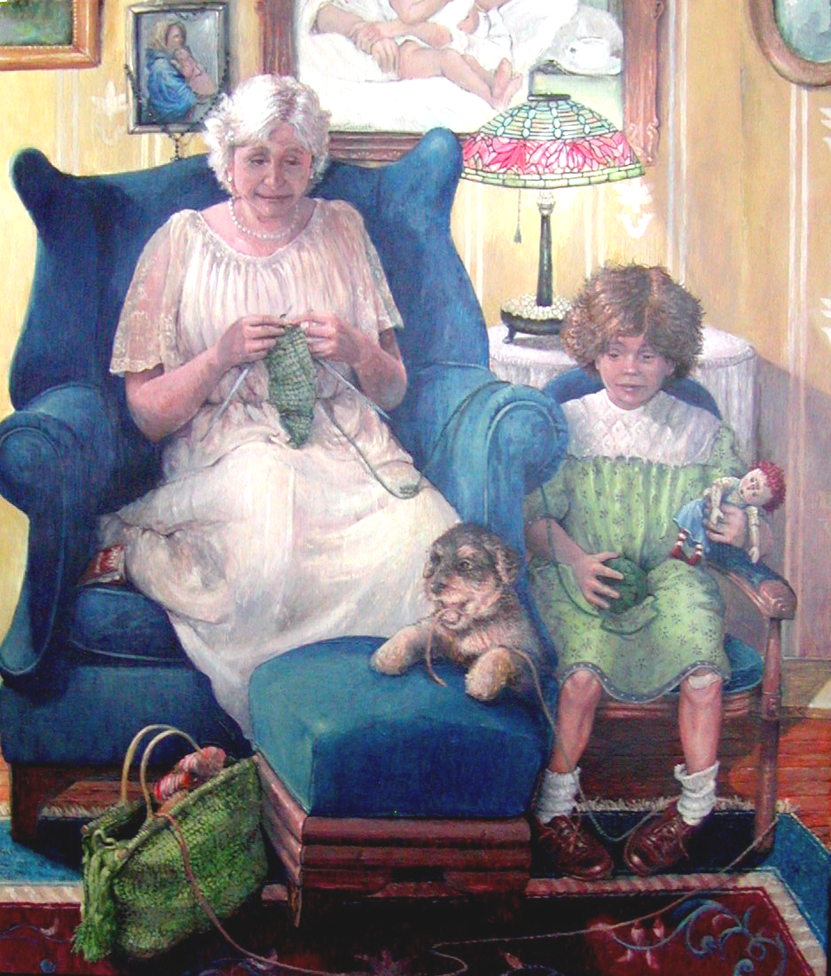
To: All Pastors of Parishes
In the Surrounding Areas of
St. James Minor of Carthage, NY

From: Bob Renaud
St. James Minor Parish
Family Rosary Crusade Organizer

‘The Lesson’
Dear Father, by artist Bob Renaud
I have included an insert explaining this event to your congregation and I ask you to include it in your bulletin.
Six years ago, I developed and organized the first Family Rosary Crusade at our parish, St. James Minor, in Carthage, NY. Since that time, many Catholics in our area have contacted me to obtain the information. Therefore, I am sending each of the surrounding parishes an insert to include in their weekly bulletin prior to the actual event to help spread the word. The date planned for this year is Friday May 30th, 2008. It is the Feast of the Sacred Heart and a wonderful way to conclude Mary’s month. I ask for your assistance in spreading the word to your congregation about this event.
To tie in my love for Our Lord and His Blessed Mother with my artistic talents, I’ve also painted a painting each year. A free signed print is given to anyone who stays to pray the Rosary for at least three hours, in honor of Our Lord who suffered three hours for us. On average I have given away over 40 prints each year. Some prayer warriors stay for ALL seven hours. People have joined us from as far as Ogdensburg, Morristown, Brownville, Alex Bay, Clayton, Cape Vincent, and Adams, with still many making the effort from the closer parishes of Watertown, Croghan, Lowville, Harrisville, and Indian River.
With the constant encouragement Our Blessed Mother has given us in the past about the Power of this Simple Tool, the Rosary, I would like to encourage everyone to act upon this request and pray for our Holy Father, our priests, families, communities, and the world.
The painting I’ve painted this year (seen above) entitled; ‘The Lesson’, depicts a grandmother and granddaughter knitting. Although this painting looks very secular at first glance, it is full of hidden religious ties which all conclude the importance of the older generation passing down traditions to our youth, including that of the Rosary. A print will be given to anyone who prays the Rosary for three or more hours at this year’s Crusade. However, people may join us in prayer for one, two, or as many hours as they wish. Each hour is listed with specific intentions (see bulletin insert) and in honor of the seven sorrows of Mary.
We will begin the evening with the most perfect prayer, the mass, at 5:15pm. I would encourage any brother priest who desires to call Father George Maroun and join him in celebrating mass. At 6:00pm, we will have exposition of the Blessed Sacrament, as well as, the first hour of the Rosary. The event will conclude at 1:00am with Benediction. Refreshments and coffee are available in our community room for anyone who plans on staying for more than one hour who may need to rejuvenate!
Please know that you are all in my prayers and I thank you for your priesthood!
Thank you also for helping spread the word about this event. If you have any questions please contact me.
With the love of Christ and His Blessed Mother,
"To recite the Rosary is nothing other than to contemplate with Mary the face of Christ."
Pope John Paul II, Rosarium Virginis Mariae

